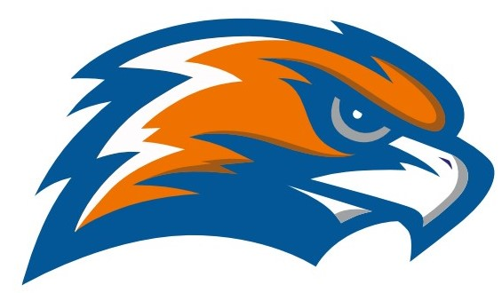

| **GARRETT MORGAN**  **BASEBALL**  **2022** |
| --- |

**Head Coach Edward Gates Assistant Coach James Hronek**

**Principal GMSEI Quenton Davis Principal GMSLI Anshawn Ivery**

**Athletic Director Jennifer Smith**

| **DATE** | **TIME** | **release** | **VISITOR** | **HOME** | **SITE** |
| --- | --- | --- | --- | --- | --- |
| Tuesday  3/15 | 4:30  scrimmage |  | Garrett Morgan | John Hay | Luke Easter |
| Thursday  3/24 | 4:00  scrimmage |  | Garrett Morgan | University School (JV) | US  Hunting Valley |
| Saturday  3/26 | 12:00 |  | Garrett Morgan | Trinity | Danko Field @ St. Monica |
| Monday  3/28 | 5:00 |  | Garrett Morgan | Open Door | Open Door Christian Acad. |
| Tuesday  3/29 | 4:30 | 2:45 | VASJ (JV) | Garrett Morgan | League Park |
| Saturday  4/2 | 9:30 am |  | Garrett Morgan | Gilmour Academy (JV) | Gilmour Academy |
| Tuesday  4/5 | 5:00 | Late bus | Lincoln West | Garrett Morgan | League Park |
| Wednesday  4/6 | 4:30 |  | Garrett Morgan | Benedictine (JV) | Luke Easter (turf) |
| Thursday  4/7 | 5:00 | 3:20 | Max Hayes | Garrett Morgan | Michael Zone |
| Tuesday  4/12 | 5:00 | 3:20 | John F. Kennedy | Garrett Morgan | Gordon 1 |
| Wednesday  4/13 | 4:30 | 2:30 | Garrett Morgan | Andrews Osborne Academy | Andrews Osborne |
| Thursday  4/14 | 5:00 | 3:20 | Garrett Morgan | Glenville | Gordon 1 |
| Tuesday  4/19 | 5:00 | 3:20 | Garrett Morgan | James F. Rhodes | Brookside 4 |
| Thursday  4/21 | 5:00 | 3:20 | Bard | Garrett Morgan | Gordon 1 |
| Friday  4/22 | 4:30 | 2:45 | Garrett Morgan | Gilmour Academy (JV) | Gilmour Academy |
| Saturday  4/23 | 11:00? |  | Garrett Morgan | University School (JV) | US  Hunting Valley |
| Tuesday  4/26 | 5:00 | 3:00 | Garrett Morgan | John Adams | C.C. Sabathia |
| Thursday  4/28 | 5:00 | 3:20 | Garrett Morgan | John Hay | Gordon 1 |
| Friday  4/29 | 4:30 | 2:45 | Archbishop Hoban (JV) | Garrett Morgan | League Park |
| Monday  5/2 | 4:30 | 2:00 | Garrett Morgan | Western Reserve Academy (JV) |  |
| Tuesday  5/3 | 5:00 | 3:20 | Garrett Morgan | John Marshall | Brookside 4 |
| Wednesday 5/6 | 4:30 | 2:45 | Trinity (JV) | Garrett Morgan | League Park |
| 5/14 - 5/21 |  |  | **OHSAA Sectionals** |  |  |
| 5/20 | 5:00 | 2:30 | Garrett Morgan | Open Door | Open Door Christian Acad. |

**PLAYOFFS**

**Thursday, May 12, 2022**

**4TH  PLACE VS. 1ST PLACE 4:00 PM TBA**

**3RD  PLACE VS. 2ND PLACE 4:00 PM TBA**

###### **CHAMPIONSHIP GAME**

##### **12:30p.m. Progressive Field**

**OHSAA SECTIONALS**

**May 14 - May 21**

**SENATE ATHLETIC LEAGUE**

**Bard**

**Garrett Morgan**

**Glenville**

**James F. Rhodes**

**John Adams**

**John Hay**

**John F. Kennedy**

**John Marshall**

**Lincoln-West**

**Max Hayes**